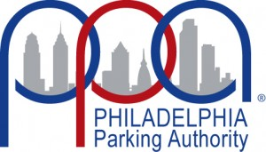

The Philadelphia Parking Authority
701 Market Street – Suite 5400
Philadelphia, PA 19106

General Construction at 6 East Oregon Avenue
Bid No. 22-14

Notice to Bidders

Sealed bids will be received until 12:00 PM on Wednesday, June 15, 2022, by the Philadelphia Parking Authority (“Authority”), a body corporate and politic created under the laws of the Commonwealth of Pennsylvania in accordance with the Act of June 19, 2001, P.L. 287, No. 22, as amended, known as the “Parking Authority Law,” in the offices of the Authority, located at 701 Market Street, Suite 5400, Philadelphia, PA 19106.

Prospective Bidders must register using the Bidder Registration Form (control-click to follow link). The bid documents will be made available electronically after registration.

Prospective Bidders are required to attend a mandatory Pre-Bid Meeting that will be held at the Philadelphia Parking Authority Offices located at 701 Market Street, Suite 5400 Philadelphia, PA 19106 on Thursday, May 26, 2022, at 11:00 AM. A site visit will occur after the Pre-Bid Meeting. Prospective Bidders must attend both the Pre-Bid Meeting and the site visit.

Prospective Bidders are encouraged to submit questions until Monday, June 6, 2022, at 12:00 PM. Please forward all questions to Mary Wheeler via email at mwheeler@philapark.org. Only questions submitted in writing will be considered.

Bids are due no later than 12:00 PM on Wednesday, June 15, 2022.

